

**USER MANUAL SIGN-OFF**

**Authorization Memorandum**

This form is to sign-off completion of the Design Phase for **CAMPUS MANAGEMENT SOFTWARE AT WORLD SKILL CENTER (WSC).**

World Skill Centre (WSC) acknowledges receipt of the deliverables as part of the Design Phase through the submission of this document.

|  |  |
| --- | --- |
| **MODULE NAME** | Infrastructure & Asset Maintenance |
| **MODULE OWNER** |  |

**WSC AUTHORITY NAME AND SIGNATURE**

**SOUL AUTHORITY NAME AND SIGNATURE**

**Sustainable Outreach And Universal**

**Leadership (SOUL) Limited**

**User Manual**

Of

**Infrastructure & Asset Maintenance Module**

For Implementation of

**Campus Management Software**

at

**World Skill Center (WSC)**

**Confidentiality**

This document is a strictly confidential communication to and solely for the use of the recipient and may not be reproduced or circulated without SOUL Ltd’s prior written consent. If you are not the intended recipient, you may not disclose or use the information in this documentation in any way

**Document Control History**

|  |  |  |  |  |
| --- | --- | --- | --- | --- |
| **Date** | **Version No.** | **Created By** | **Affected Sections** | **Reviewed By** |
|  |  |  |  | Sharmistha Panda |

Table Of Contents

USER MANUAL SIGN-OFF 1

Authorization Memorandum 1

1 Introduction 5

1.1 Background 5

1.2 Scope and Purpose of the document 5

2 General Procedures 6

2.1 General Procedure for Save Screen 6

2.2 General Procedure for Submitted Document 11

3 Infrastructure Masters 14

3.1 Land 14

3.2 Buildings 15

3.3 Floor 16

3.4 Building Type room 18

3.5 Building Room 19

4 Asset Maintenance 20

4.1 Asset 20

4.2 Asset Maintenance Team 22

4.3 Asset Maintenance 23

4.4 Asset Maintenance 24

4.5 Asset Maintenance 26

5 Roles and Permissions 27

5.1 Land 27

5.2 Buildings 27

5.3 Floor 27

5.4 Building Type room 27

5.5 Building Room 28

5.6 Asset 28

5.7 Asset Maintenance Team 28

5.8 Asset Maintenance 28

5.9 Asset Maintenance 29

5.10 Asset Maintenance 29

# Introduction

The World Skill Center (WSC) is a premier advanced skill training institute established by the Government of Odisha, Skill Development and Technical Education Department, through the Odisha Skill Development Authority (OSDA). The WSC will impart advanced skill training in eight trades from engineering and service sectors. WSC caters primarily to induct the best talent from ITIs and Polytechnics and training them to become globally employable in emerging areas such as "Industry 4.0". WSC is housed in a state-of-the-art, 18-storey, air-conditioned building with nearly half a million square feet of space in the heart of capital city of Bhubaneswar.

With the implementation of campus management software for WSC the goal is to streamline the operations and functions of the campus by integrating various processes, such as admissions, course registration, academic progress tracking, and financial management, HRMS, Procurement and Inventory management, etc into a unified system. The implementation also aims at providing a user-friendly interface for all stakeholders, making it easier for them to access the necessary information and complete their tasks with ease. The modules to be covered during the implementation of the software include:

|  |  |
| --- | --- |
| Students Management Modules | Infrastructure Management |
| Academic System | Finance and Accounting System |
| Procurement & Inventory Management | Training and Placement |
| Human Resources Management System | Application Integration |

# 

## Background

The Web Based Campus Management Application at World Skill Centre (WSC) application is required by WSC for the smooth operation of all departments / support functions with on-line delivery of services to all stakeholders.

The project aims to create a mechanism to provide the basis for evolution of an IT enabled state of the art workflow automation system in a planned manner.

## Scope and Purpose of the document

A user manual is a document provided to a user that helps in using a particular system, product or service seamlessly. It is also known as an instruction manual or a user guide. Such documents cover detailed information around operations, standards & guidelines, [troubleshooting guides](https://document360.com/blog/troubleshooting-guide/" \t "https://document360.com/blog/creating-a-user-manual/_blank), functionalities & more.

This document covers all the functional requirements of **Infrastructure & Asset maintenance** module. This module helps in organizing the infrastructure of an organization from land, building, floors and its rooms. The modules also help in maintenance of the Assets present on the floor as well as floors.

# General Procedures

## General Procedure for Save Screen

**Create New document**

Login on to the system

Go to the required workspace

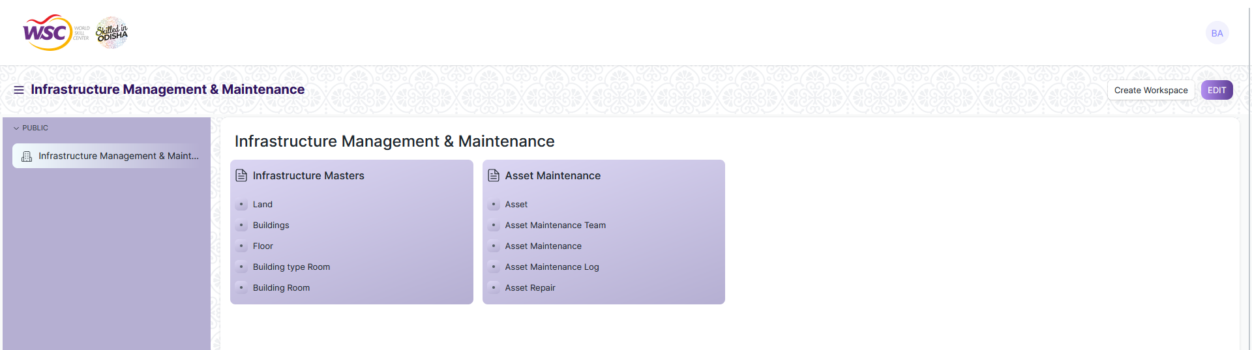

* Go to the required screen.
* Click on the ***“+Add Screen Name”*** button in the right corner of the screen.

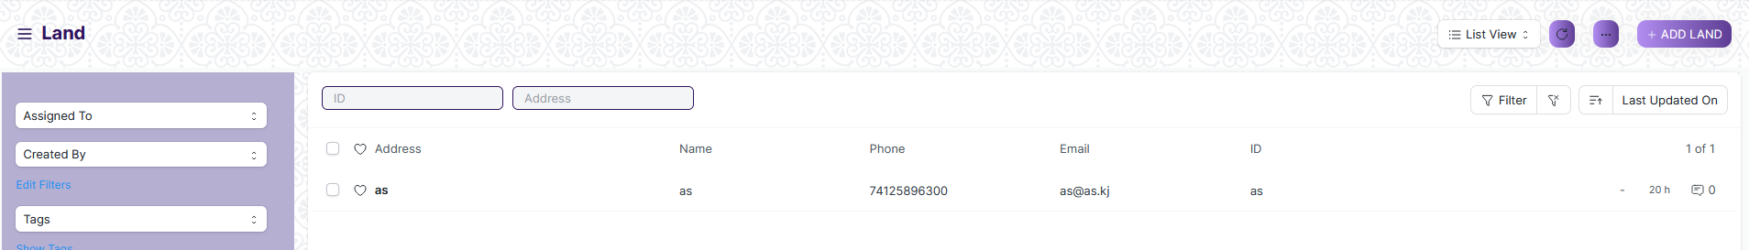

(Example : For addition in the new Land form , click +Add Land button)

* Enter the required data.
* Click on “***Save”*.**
* After saving , the record will be visible in the List View of the screen.



(Example : List view of saved Land)

**Note :** The process of creation can only be carried out by User who have necessary permission.Kindly refer to the Screen wise permission section in the document.

**View a Saved Document**

* Log in to the system.
* Go to the required workspace
* Go to the required screen.
* Click on the required document from the list view of the screen.



(Example : View of “as” Document of Land Screen)

View the clicked document.

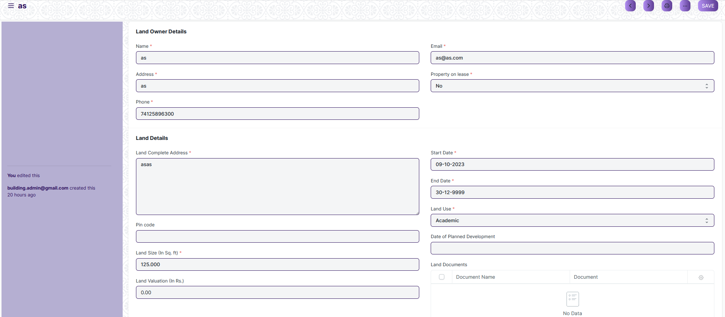

(Example : View of the “as” Land)

**Note :** The process of view can only be carried out by employees who have necessary permission.Kindly refer to the Screen wise permission section in the document.

**Delete a Saved Document**

* Log in to the system
* Go to the required workspace
* Go to the required screen.
* Click on the required document from the list view of the screen.
* Click on the 3 dots in the right corner of the screen.
* Click on *“****Delete”*.**

**Note :** If the document you are deleting is linked with any other document then first unlink it , then try to delete.

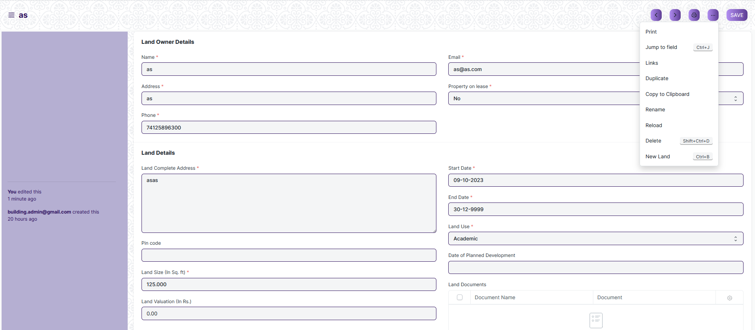

(Example : Deletion of “as” document of Land)

* Click yes if you want to delete the selected document.

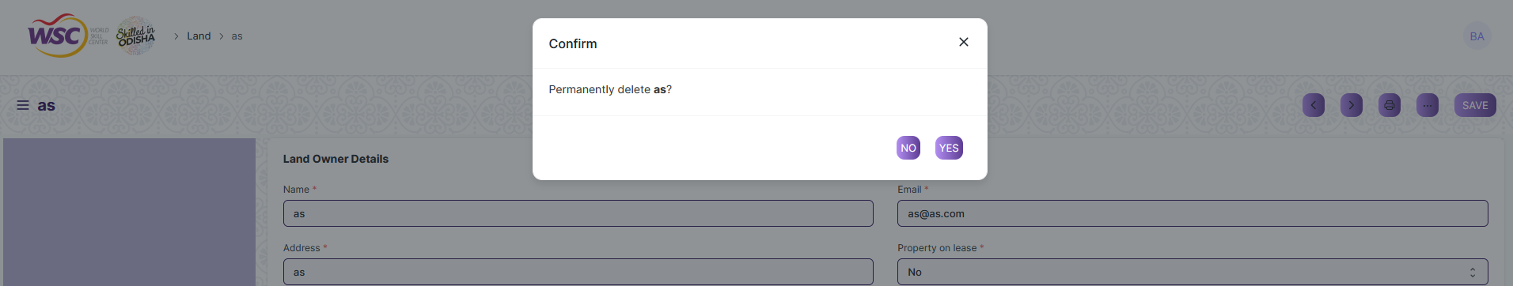

(Example : Clicking Yes to Delete permanently the document)

**Note :** The process of deletion can only be carried out by employees who have necessary permission.Kindly refer to the Screen wise permission section in the document.

**Rename a Saved Document**

* Login to the screen.
* Go to the required workspace
* Go to the required screen.
* Click on the required document from the list view of the screen.
* Click on the 3 dots in the right corner of the screen.
* Click on *“****RENAME”*** .



* Click on *“****Rename”*** button to rename the document.

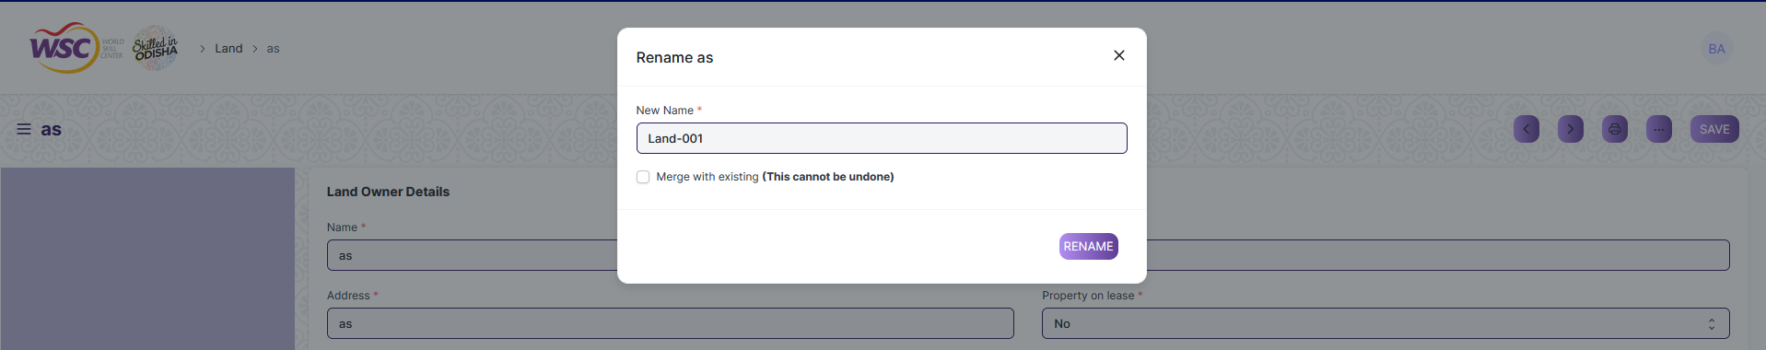

**Note :** The process of deletion can only be carried out by employees who have necessary permission.Kindly refer to the Screen wise permission section in the document.

**Print a Saved Document type**

* Login to the system
* Go to the required workspace
* Go to the required screen.
* Click on a saved document on the screen.
* Click on the print button presented in the right corner of the screen.

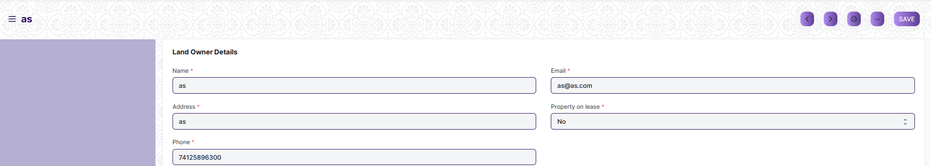

* A new screen will open.
* Click on the print button to print the document.

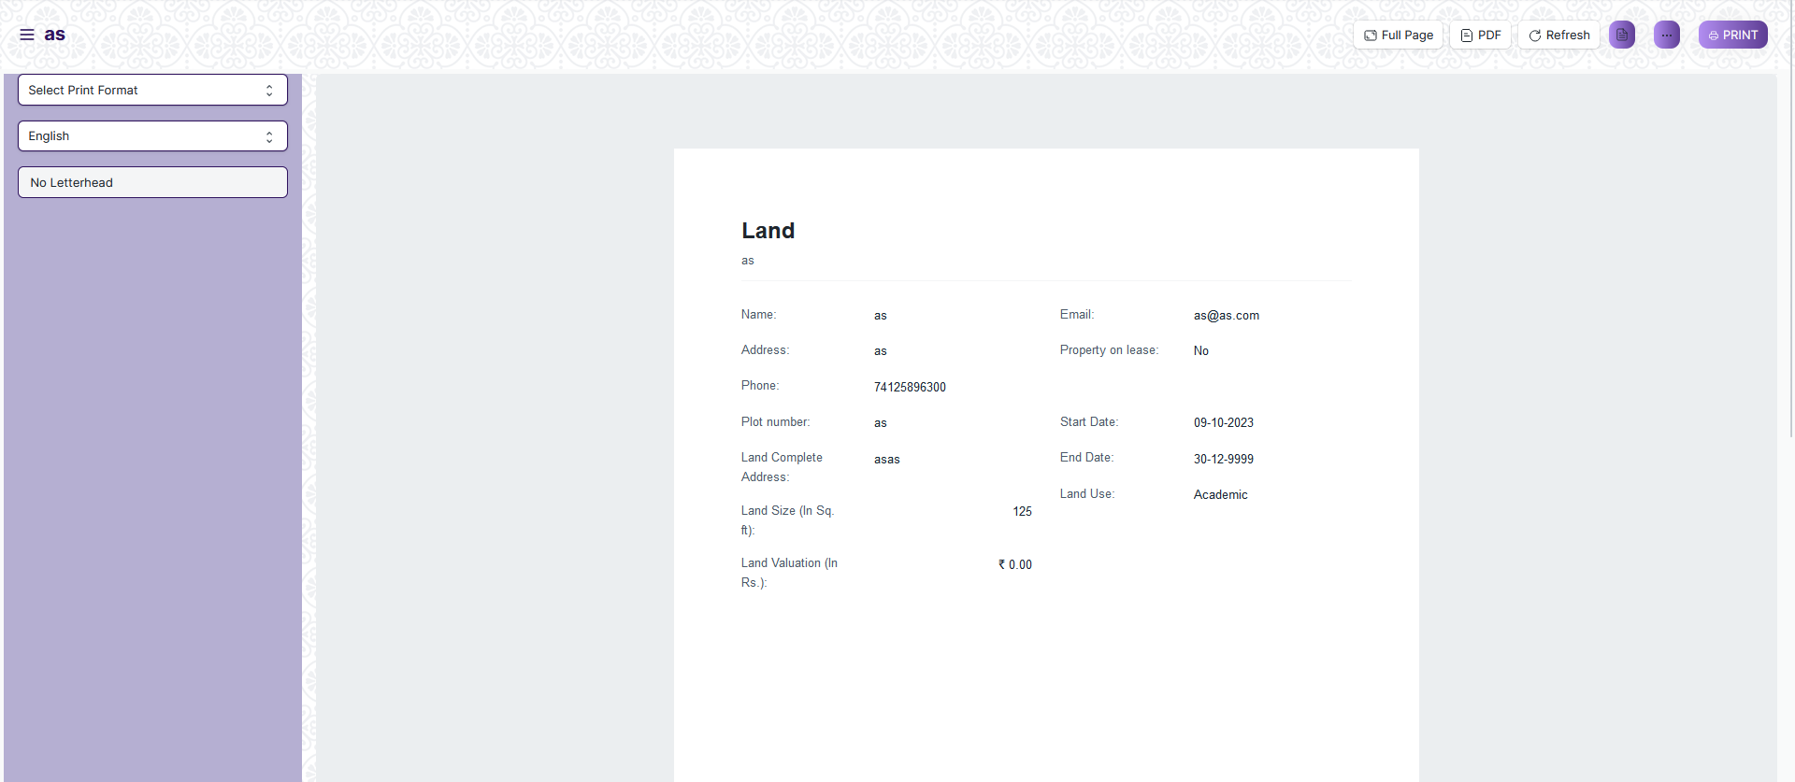

* To download the Land as PDF , click on the PDF button.



**Note :** The process of printing can only be carried out by employees who have the necessary permission.

**View the saved document in different format.**

* Login to the system
* Go to the required workspace
* Go to the required screen.
* Click on the List View Button in the screen.

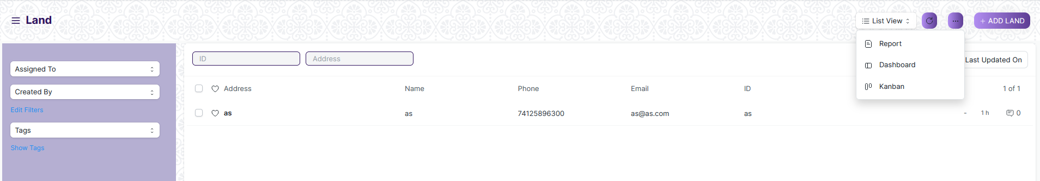

* Select the appropriate view type that you want.

**Note :** The List view button can only be showed to the employees who have necessary permission.

**View the saved documents by applying filters.**

* Login to the screen.
* Go to the required workspace.
* Go to the required screen.
* Click on the ***“Filter”***.

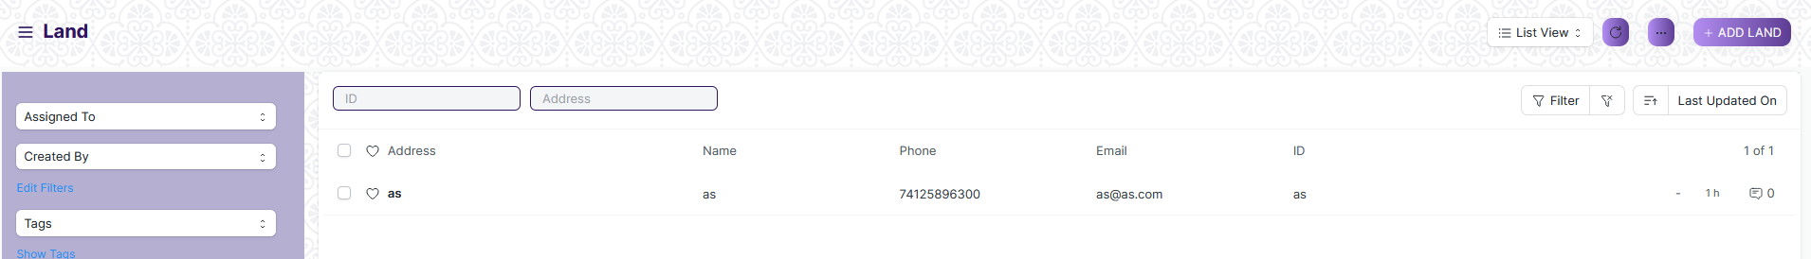

* Select the field of the document based on which you wish to filter the records. All the fields in a form will be selectable in this list.

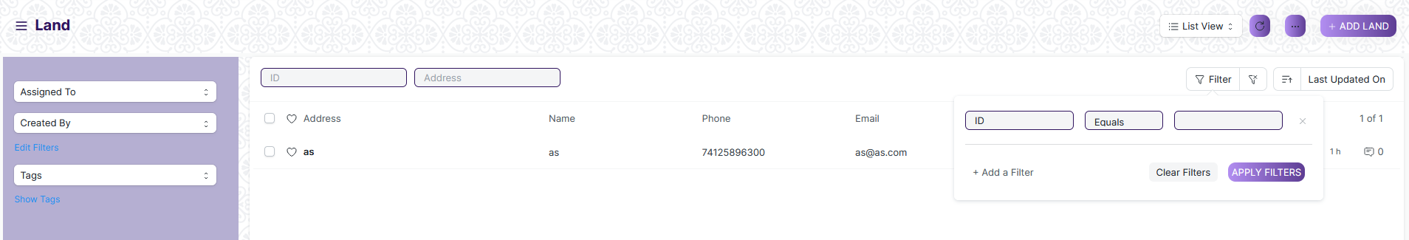

Value

Based on

Criteria

**Based On :** For the field, you will be required to put a value of the field. In the 'based on' field.

**Criteria :** You can define criteria based on which the system will search the document.The different conditions on which the filters are based are: Equals, Not Equal, Like, Not Like, In, Not In, =,>,< etc.

**Value :** Here, you will be required to enter the value for which you are running the document search.

**Some Examples of Viewing the documents in the list view after applying filters.**

Filter on Building Type room screen where Is Group Equals to Yes. After clicking the Apply Filter button, all the filtered document will show in the screen.

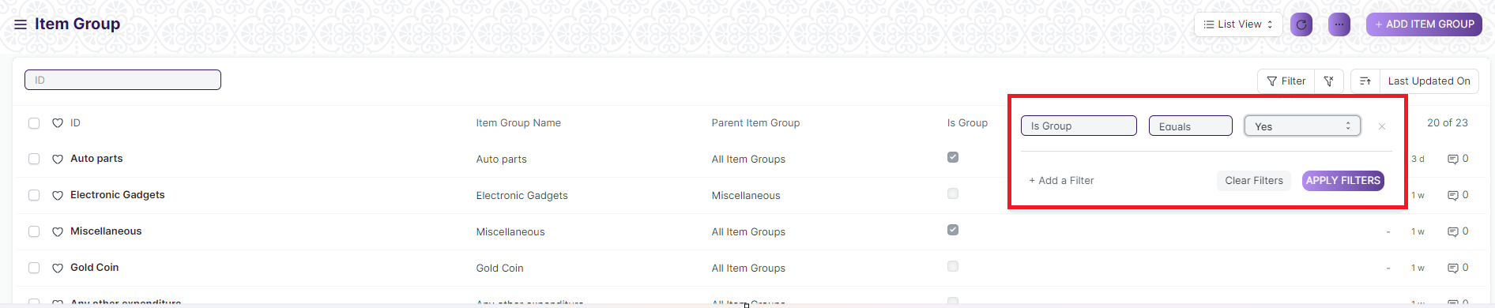

Filter on Building Type room Screen where, the Document Name starts with ‘A’.

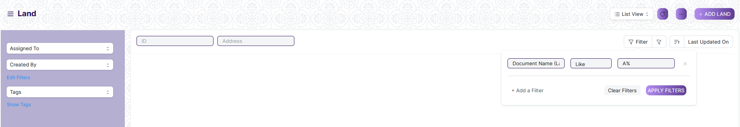

You can also apply multiple filters at a time. To remove a specific filter, just click on 'x' sign on it. To add another filter Click on the +Add a Filter button.

**Example of Multiple filter .**

Applying filter in Land screen , where the Land starts with ‘A’. and ID equals as.

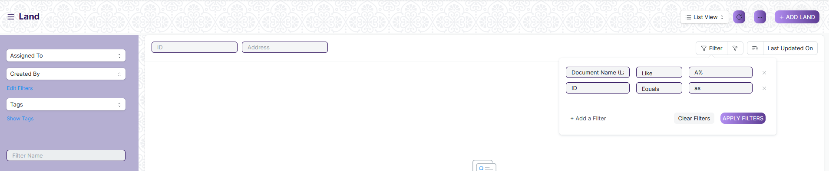

**Default Filters**

There are some filters present out of the box for the views which can be used for filtering the search results.

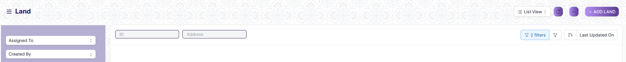

**Note :** The Filter Option can only be showed to the User who have necessary permission.

## General Procedure for Submitted Document

**Create of New document**

* Login in to the system
* Go the required workspace
* Go to the required screen.
* Click on the ***“+Add Screen Name”*** button in the right corner of the screen.

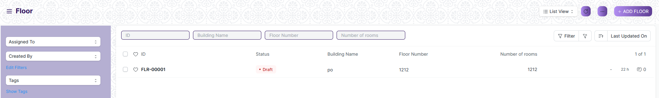

(Example : For addition in the new Floor , click +Add Floor button).

* Enter the required information in the document.
* Once you are finished entering the information , click the ***“Save”*** button.
* After saving it , a submit button will appear.

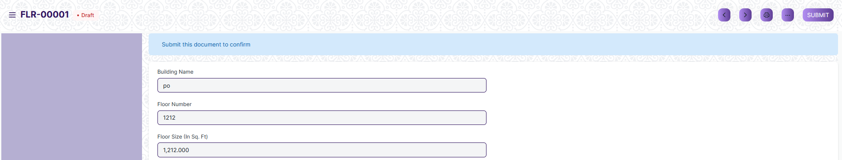

* Click on the **“Submit”** button.
* A confirmation dialog box will appear . Click the Yes button to submit the document.

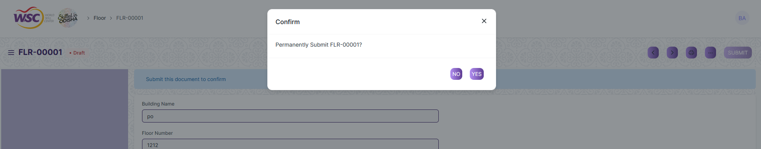

* After submitting , the record will be visible in the List View of the screen.

**Note :** The process of creation can only be carried out by employees who have necessary permission.Kindly refer to the Screen wise permission section in the document.

**Cancel a Submitted Document**

* Log in to the system.
* Go to the required workspace
* Go to the required screen.
* Click on the required document from the list view of the screen.
* Click the ***“Cancel”*** Button .

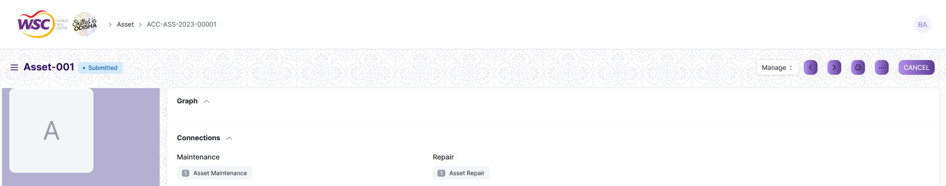

* A confirmation dialog box will appear . Click the Yes button to cancel the document.

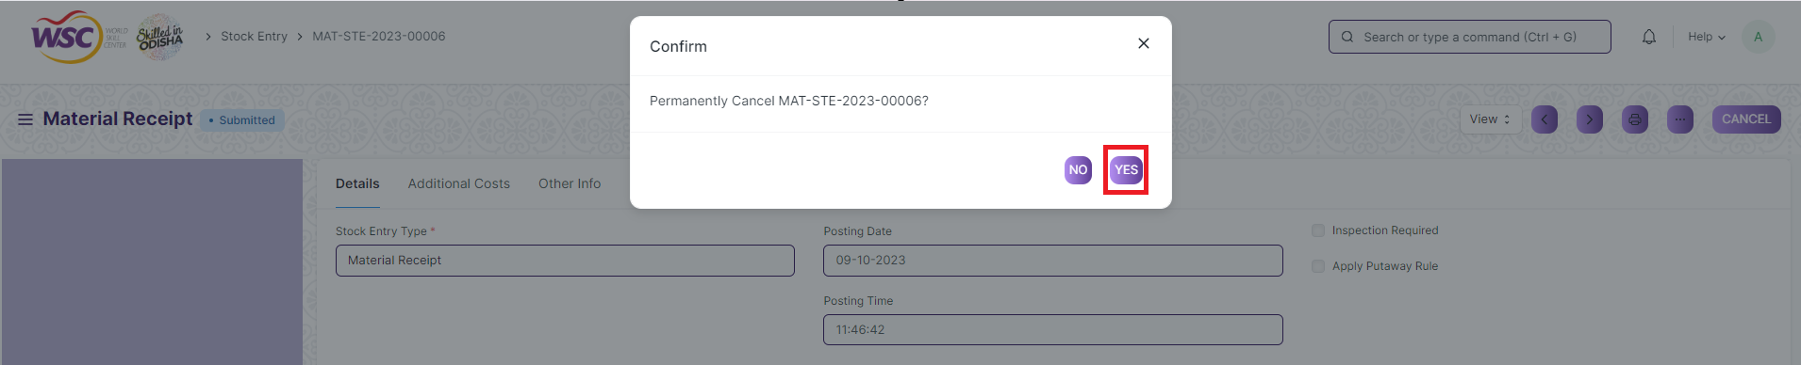

**Note :** The process of cancellation can only be carried out by employees who have necessary permission.Kindly refer to the Screen wise permission section in the document.

**Amend a Submittable Document**

* Log in to the system.
* Go to the required workspace
* Go to the required screen.
* Click on the required document from the list view of the screen.
* After cancellation of the document , an Amend button will appear on the screen.

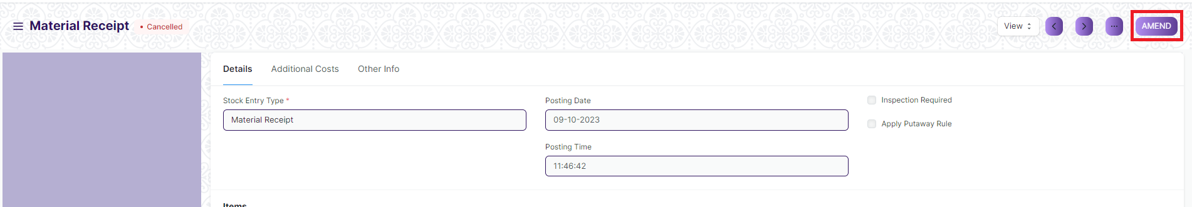

* Click the “***Amend”*** button.
* A new document will be created with the same information as the original document .



* You can now make changes to the document as needed.

**Note :** The process of Amend can only be carried out by employees who have necessary permission. Kindly refer to the Screen wise permission section in the document.

**Action Menu on a document.**

The three dots menu, located in the right corner of a document in a Screen , offers a range of actions and options to manage and interact with the document.

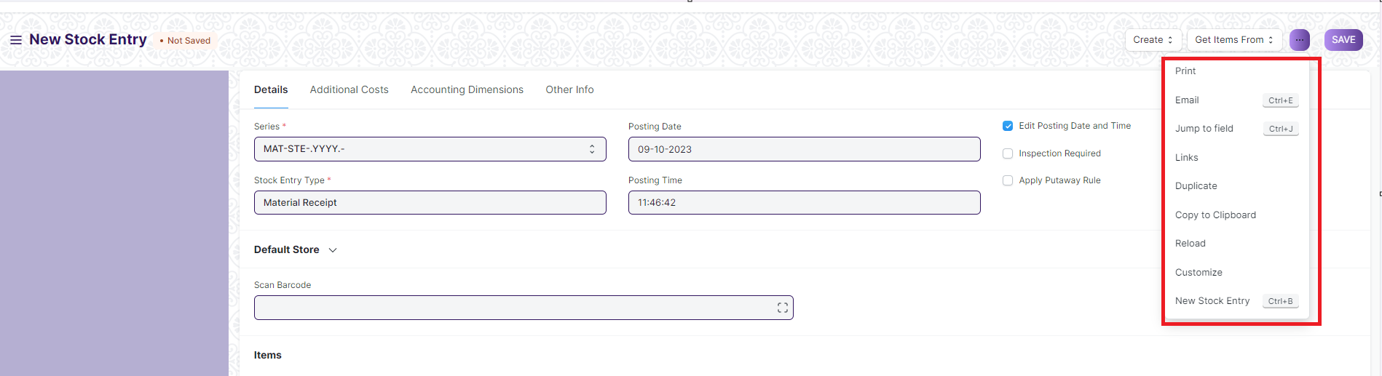

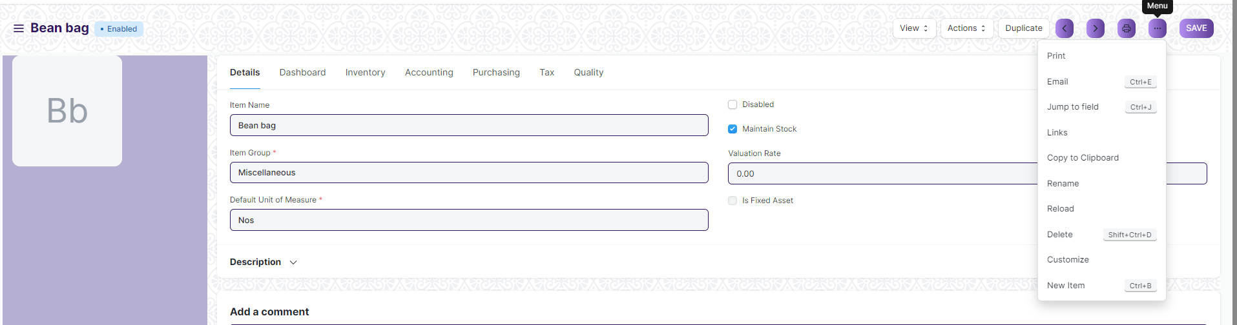

The functionalities available in the three dots menu are given below .

**Print :** Print Enables you to generate a printable version of the document ., which you can save as a PDF or send to a printer.

**Email :** Click on Email allows you to send the document as an attachment via email to specified recipients.

**Duplicate :** Create a new document with the same information as the current one.

**Delete :** Permanently remove the document.

**Cancel :** Cancel the submitted document.

**Submit :** Submit the document . If the document is submittable.

**Links :** This Option displays a list of document that are linked to the current document. You can navigate these linked documents from here.

**Jump to field :** You can directly go the required field by clicking this option and giving appropriate field name.

**Copy to Clipboard :** By clicking this option you can copy the content of the document .

**Rename :** By clicking the Rename option you can Rename the document.

**Note :** These options will be visible to User who have necessary permission.

# Infrastructure Masters

## Land

This is a master screen which holds data regarding the land. Land here is in reference to the plot of land on which the building is built. The Land Master shall have attachment buttons for Allotment Letter and other documents.

The screen is accessible to Building Administrator, Floor Supervisor, Maintenance Department, Employee

To access the Land List ,go to :

***Home > Infrastructure Management & Maintenance > Infrastructure Masters > Land***

Screen Type : Save

**Adding a new Land**

As it is a save screen, follow the general procedure to create a save document as mentioned above .

* Go to Land list, click on New
* Enter details Like Land Owner details like Name, Address, Phone, Email, Property on lease, Land details like Plot number, Land complete address, Pincode, land size, land valuation, start date, end date Land use, Date of planned development, land documents
* Save the form

After creating an Land , the record will be visible in the List view of the screen.

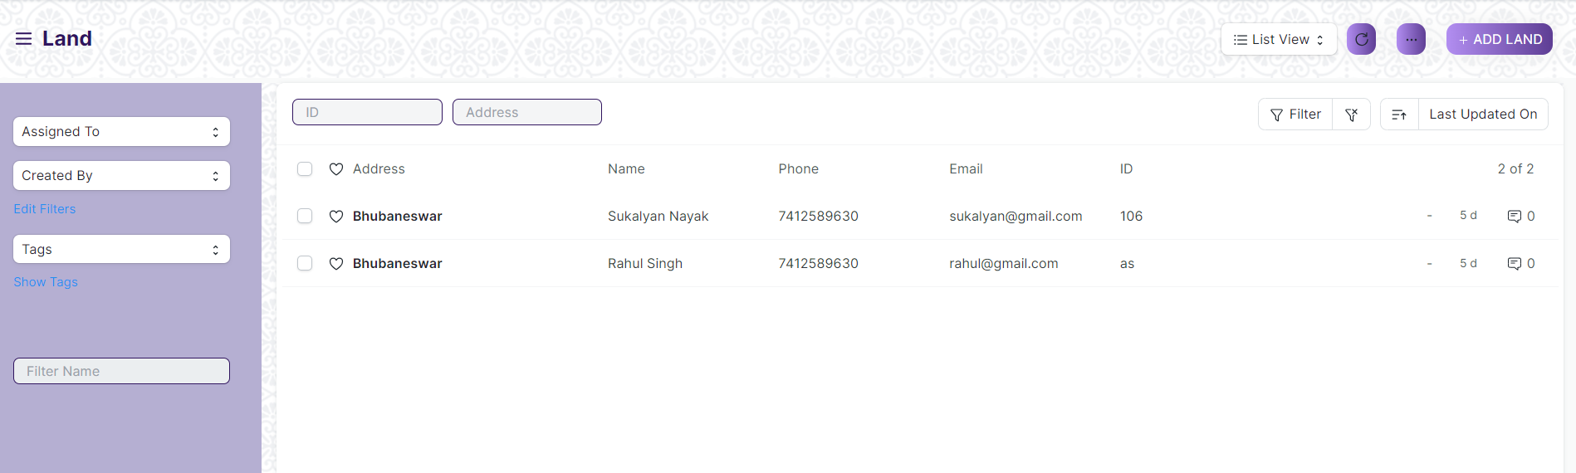

(List View of Land)

**View Land**

As it is a Save screen, follow the general procedure to view a save document as mentioned above .

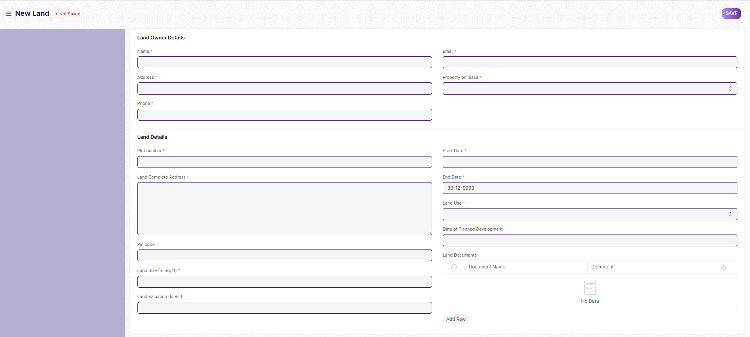

(View of a save Land)

**Delete Land**

As it a save screen , follow the general procedure to delete a save document .

**Edit Land**

Edit the field that you want to change.

Click on Save.

**Print Land**

As it is a save screen , follow the general procedure to print a save document.

## Buildings

This is a master screen for buildings. All the building information shall be stored here including documents like Building Letter(Records of right and Building design), Fire Approval, Electrical Inspection, etc. The buildings can be residential, academic or both. The actions on this screen can be performed by the administrator only.

The screen is accessible to Building Administrator, Floor Supervisor, Maintenance Department, Employee

To access the Building List ,go to :

***Home > Infrastructure Management & Maintenance > Infrastructure Masters > Buildings***

Screen Type : Save

**Adding a new Buildings**

As it is a save screen, follow the general procedure to create a save document as mentioned above .

* Go to the Buildings list, click on new
* Select a Land
* On the basis of Land, Land Address will auto-fetched
* Enter the Building name, Post Office, select District based on which State will be auto fetched
* Enter Pin code, Building on Lease, Building details like Building type, Total rooms, Total Floors, Facing, Campus, Start date, End date, Building documents, etc
* Click on Save

After creating an Buildings, the record will be visible in the List view of the screen.

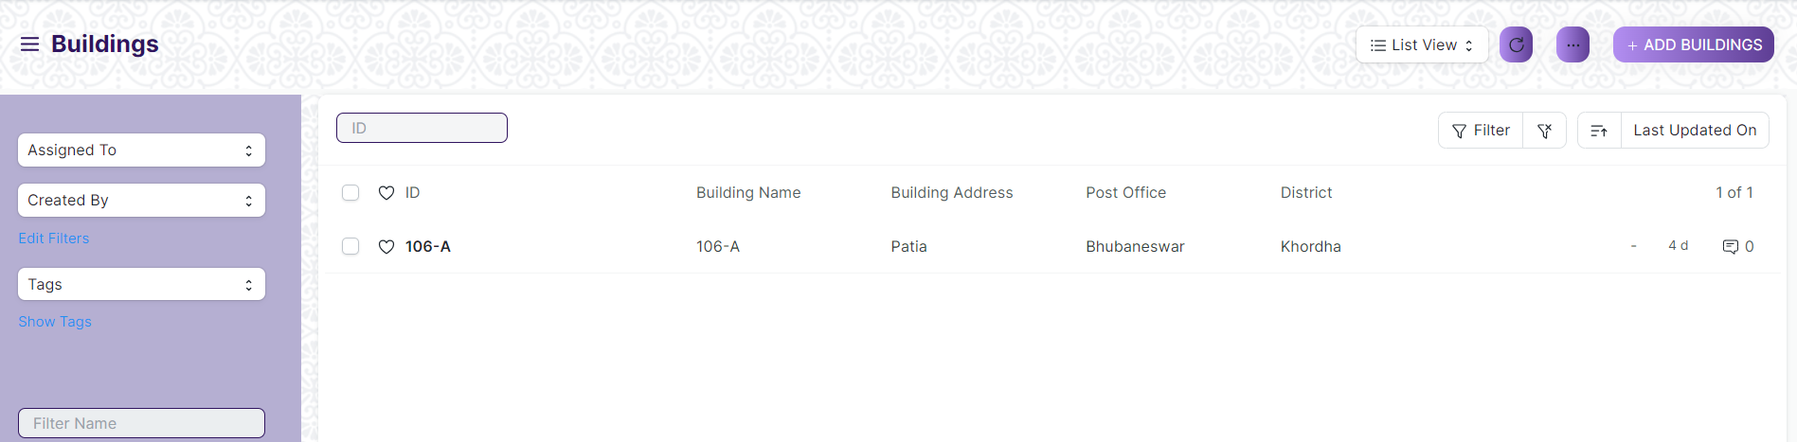

(List View of Buildings)

**View Buildings**

As it is a Save screen, follow the general procedure to view a save document as mentioned above .

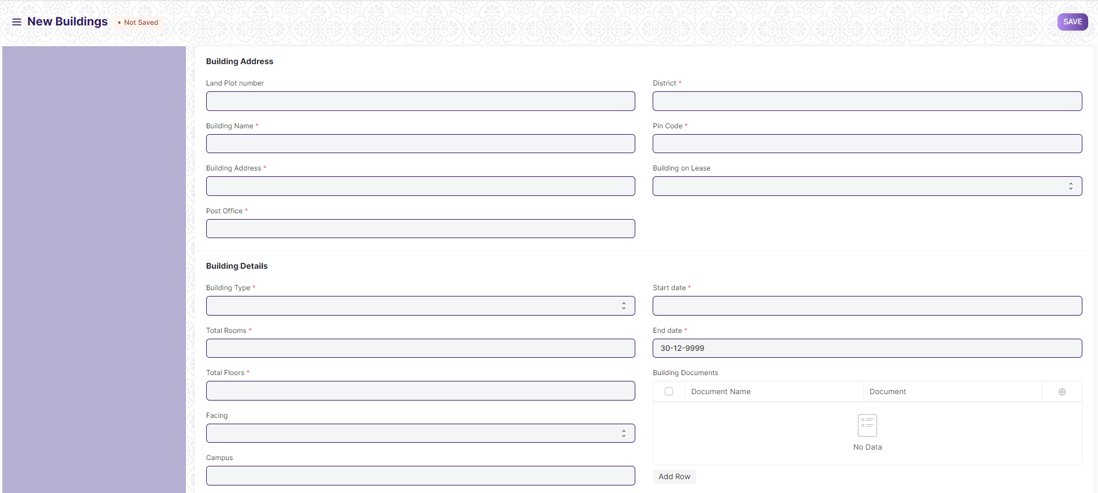

(View of a save Buildings)

**Delete Buildings**

As it a save screen , follow the general procedure to delete a save document .

**Edit Buildings**

Edit the field that you want to change.

Click on Save.

**Print Buildings**

As it is a save screen , follow the general procedure to print a save document.

## Floor

Floor Master Screen is a screen which will help the user to manage and track the layout of a building's floors and associated fixed assets. It provides an interface that allows users to view floor plans, assign fixed assets to specific locations, and record important maintenance information.

The screen is accessible to Building Administrator, Floor Supervisor, Maintenance Department, Employee

To access the Floor List ,go to :

***Home > Infrastructure Management & Maintenance > Infrastructure Masters > Floor***

Screen Type : Save

**Adding a new Floor**

As it is a Save screen, follow the general procedure to create a Save document as mentioned above .

* Go to Floor list and Click on New
* Select Building name, enter Floor number, Floor size, Number of rooms, Floor Incharge
* Attach Floor Plan
* Enter Floor Assets like Item code, Item name, Location, Asset name, Custodian. Floor documents like Document name, Document
* Click on Save.

After creating an Floor, the record will be visible in the List view of the screen.

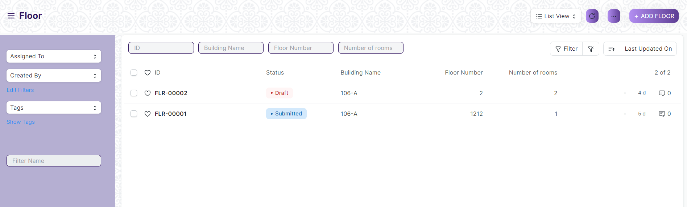

(List View of Floor)

**View Floor**

As it is a Save screen, follow the general procedure to view a Save document as mentioned above .

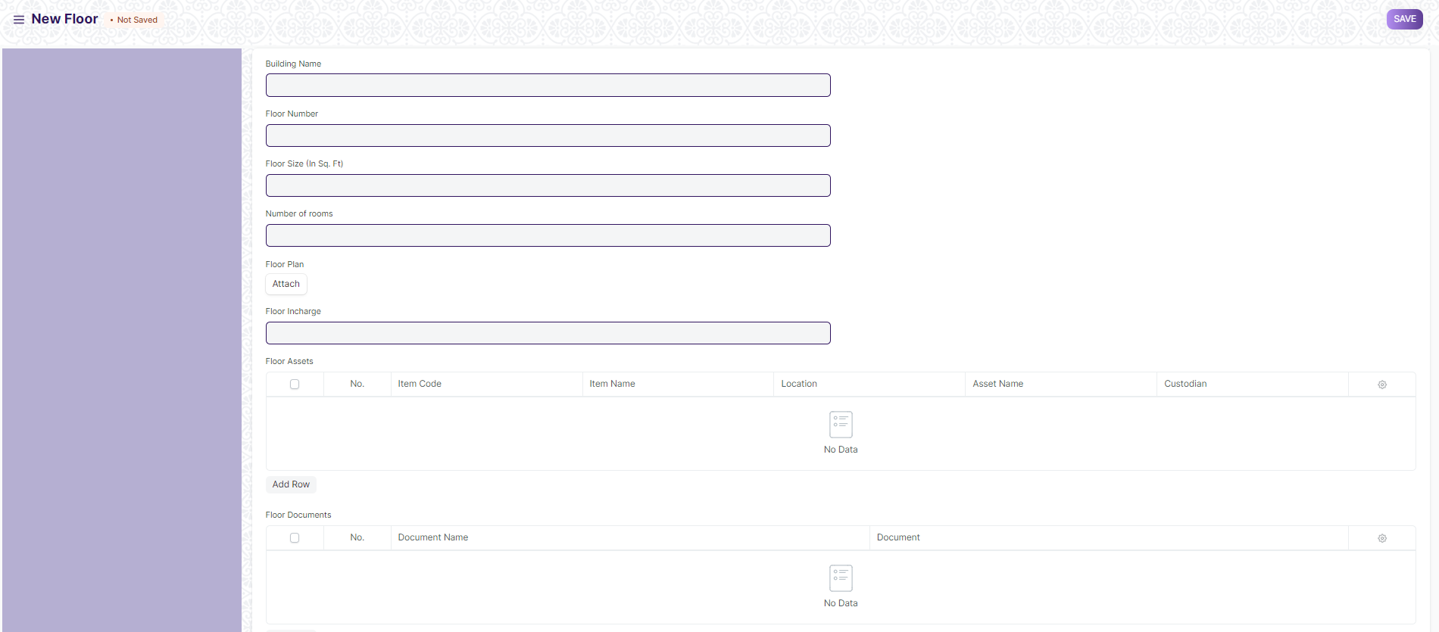

(View of a Save Floor)

**Delete Floor**

As it a Save screen , follow the general procedure to delete a Save document .

**Edit Floor**

Edit the field that you want to change.

Click on Save.

**Print Floor**

As it is a Save screen , follow the general procedure to print a Save document.

## Building Type room

This screen helps define the type of the room, for example if it is a classroom or residential or conference hall. The operations on this screen can be performed by the Administrator only.

The screen is accessible to Building Administrator, Floor Supervisor, Maintenance Department, Employee

To access the Building Type room List ,go to :

***Home > Infrastructure Management & Maintenance > Infrastructure Masters > Building Type room***

Screen Type : Save

**Adding a new Building Type room**

As it is a save screen, follow the general procedure to create a save document as mentioned above .

* Enter Type of room.
* Click on Save.

After creating an Floor, the record will be visible in the List view of the screen.

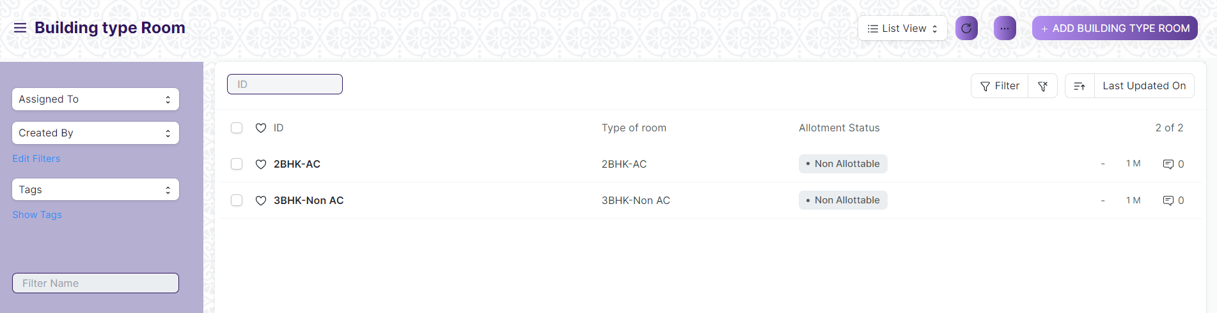

(List View of Building Type room)

**View Building Type room**

As it is a Save screen, follow the general procedure to view a Save document as mentioned above .

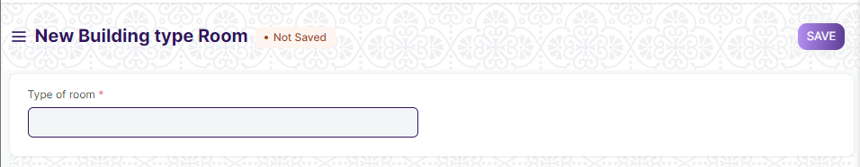

(View of a Save Building Type room)

**Delete Building Type room**

As it a Save screen , follow the general procedure to delete a Save document .

**Edit Building Type room**

Edit the field that you want to change.

Click on Save.

**Print Building Type room**

As it is a Save screen , follow the general procedure to print a Save document.

## Building Room

This is a master screen, in which we shall be storing the building’s room details and classifying the rooms. This screen also help us assign a number to the residence ( For e.g, Residence number).

The screen is accessible to Building Administrator, Floor Supervisor, Maintenance Department, Employee

To access the Building room List ,go to :

***Home > Infrastructure Management & Maintenance > Infrastructure Masters > Building Room***

Screen Type : Save

**Adding a new Building Room**

As it is a Save screen, follow the general procedure to create a Save document as mentioned above .

* Go to the Building room list and click on New.
* Select Building name, based on which Building type, Building address, Buildings Land Plot number, District, State, Pin code will be auto fetched.
* Enter Room No., Floor, Type of room, Start date, end date
* Select If temporary if that room is not permanently and Is Scheduled if the room is a permanent room
* If Is Scheduled is ticked, enter Seating Capacity and Room Name
* Enter Room Assets like Item Code, Item Name, Location, Asset Name, Custodian, Department
* Click on Save.

After creating an Building room, the record will be visible in the List view of the screen.

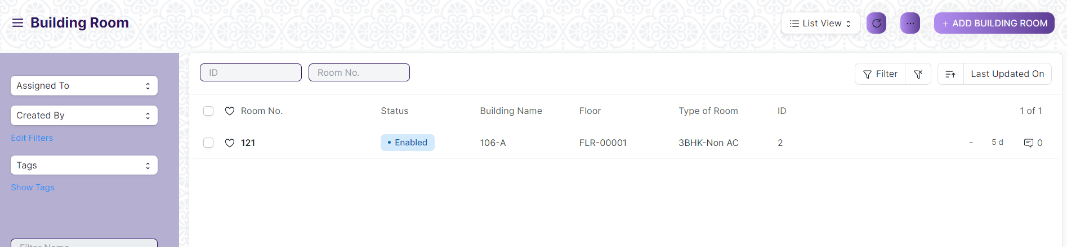

(List View of Building room)

**View Building Room**

As it is a Save screen, follow the general procedure to view a Save document as mentioned above .

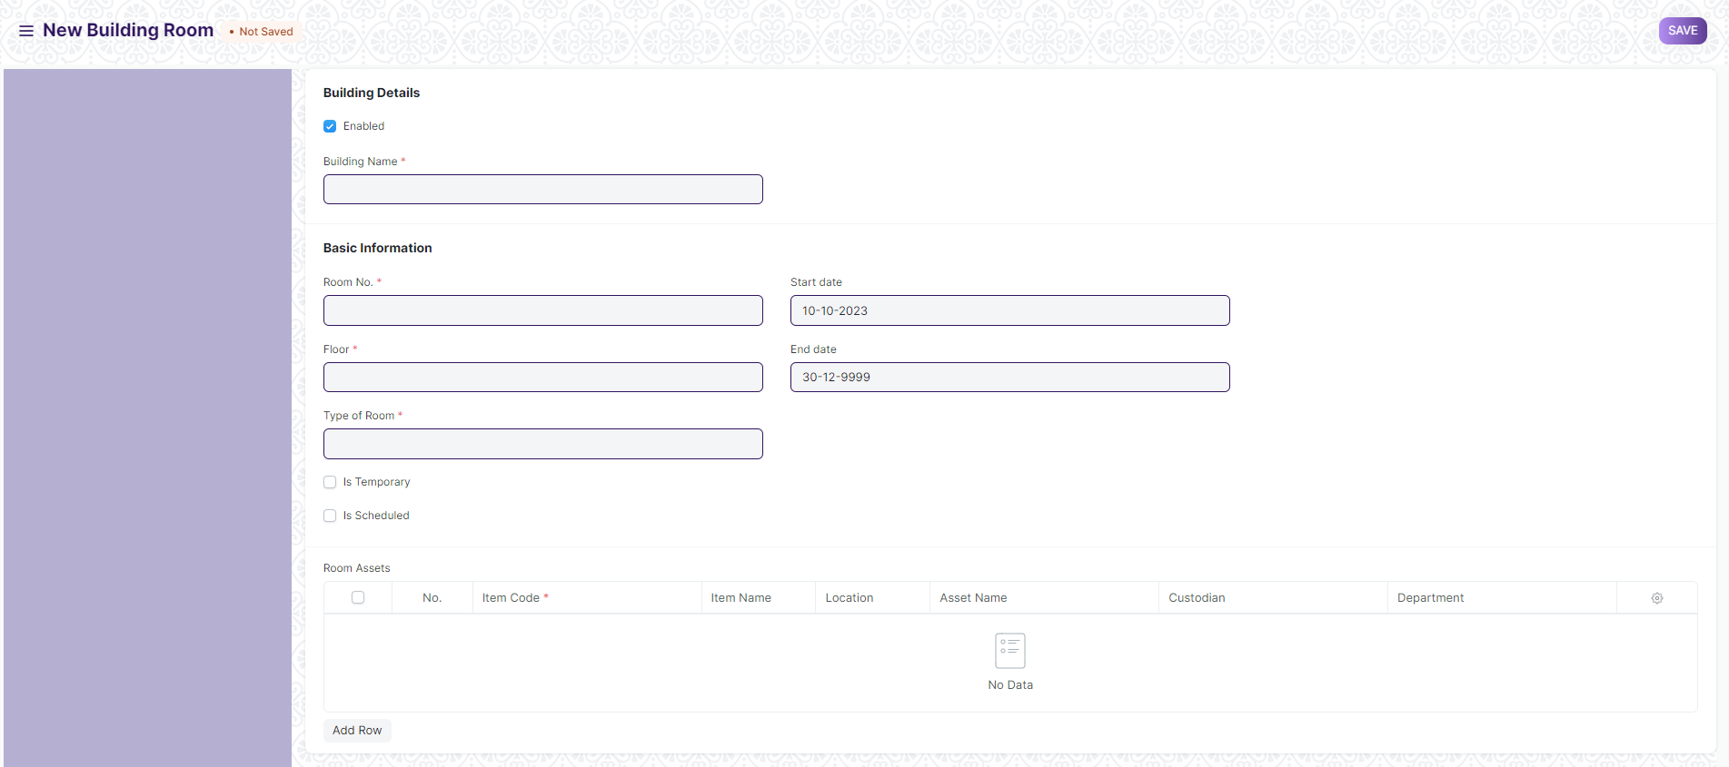

(View of a Save Building room)

**Delete Building Room**

As it a Save screen , follow the general procedure to delete a Save document .

**Edit Building Room**

Edit the field that you want to change.

Click on Save.

**Print Building Room**

As it is a Save screen , follow the general procedure to print a Save document.

# Asset Maintenance

## Asset

An Asset is any valuable Item owned by a Company.

Furniture, computers, mobile phones, printers, cars, manufacturing equipment are examples of assets. Generally, an asset is a tangible item that is located on the company premises or is carried by an employee. In some cases, an asset could be an intangible item.

An asset's useful life spans across multiple years and hence its economic value is spread over corresponding years from the accounting perspective. If you buy a printer for $300 and it is expected to be useful for three years, from the accounting perspective $100 is recorded as the expense for three years each instead of all the $300 in the first year. Most countries have rules for such calculations.

The Asset record is the heart of asset management module. All the transactions related to an Asset like purchasing, depreciation, maintenance, movement, scrapping, sales will be recorded against the Asset record.

The screen is accessible to Building Administrator, Floor Supervisor, Maintenance Department, Employee

To access Asset, go to:

***Home > Infrastructure Management & Maintenance >Asset Maintenance > Asset***

Screen Type : Submit

**Adding a new Asset**

As it is a Submit screen, follow the general procedure to create a Submit document as mentioned above .

* Go to the Assets list, click on New.
* Enter a name for the asset.
* Select the Item Code. Item Name and Asset Category will be fetched automatically.
* Select the Asset Owner, i.e. Company, Supplier, or Customer.
* Select the Company/Supplier/Customer.
* Select the Purchase Receipt/Purchase Invoice. Purchase Date and Gross Purchase Amount will be fetched automatically.
* Select a Location. Eg: Mumbai Office. This will be fetched automatically if specified in Purchase Receipt items table
* Set Available-for-use Date. The depreciation will be calculated starting from this date.
* Click on Save and Submit.

After creating an Asset, the record will be visible in the List view of the screen.

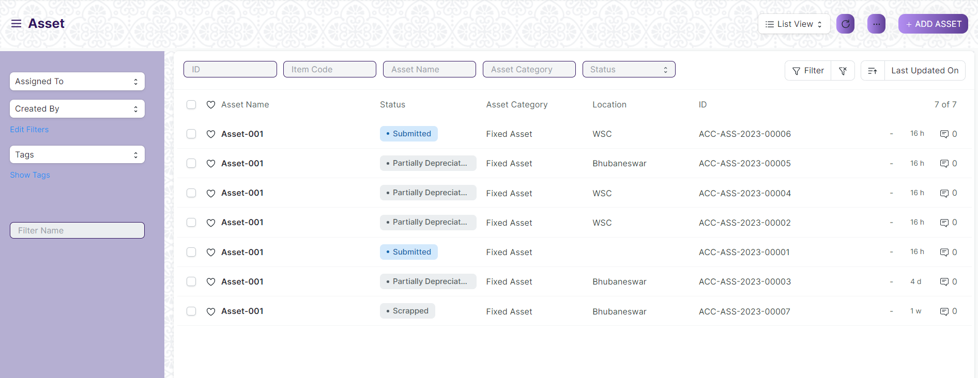

(List View of Asset)

**View Asset**

As it is a Submit screen, follow the general procedure to view a Submit document as mentioned above .

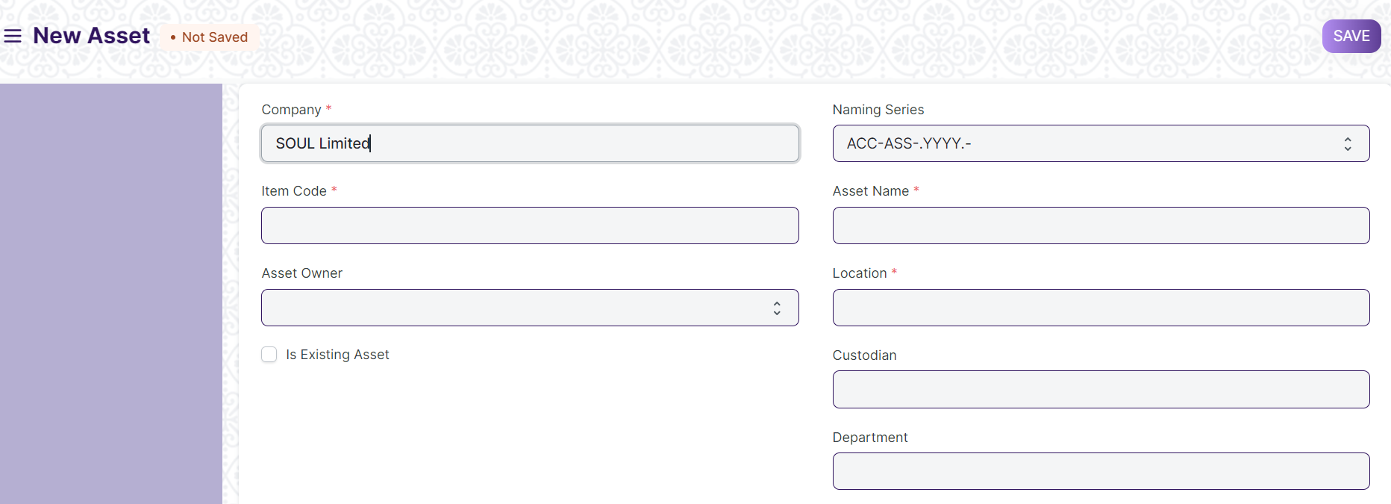

(View of a Submit Asset)

**Delete Asset**

As it a Submit screen , follow the general procedure to delete a submitted document .

**Edit Asset**

Edit the field that you want to change.

Click on Save.

**Print Asset**

As it is a submitted screen , follow the general procedure to print a submitted document.

## Asset Maintenance Team

The Asset Maintenance Team is responsible for carrying out maintenance activities on the Asset.

The maintenance activities can be cleaning, polishing, servicing, or any other activity required to maintain the Asset in good condition.

The screen is accessible to Building Administrator, Floor Supervisor, Maintenance Department, Employee

To access the Asset Maintenance Team List ,go to :

***Home > Infrastructure Management & Maintenance >Asset Maintenance > Asset Maintenance Team***

Screen Type : Save

**Adding a new Asset Maintenance Team**

As it is a Save screen, follow the general procedure to create a Save document as mentioned above .

* Go to the Asset Maintenance Team list, click on New.
* Enter a name for the team.
* Select a manager for the team.
* In the Maintenance Team Members table, add the team members and select their maintenance [roles](https://docs.erpnext.com/docs/v13/user/manual/en/setting-up/users-and-permissions/role-and-role-profile).
* Save.

After creating an Asset Maintenance Team, the record will be visible in the List view of the screen.

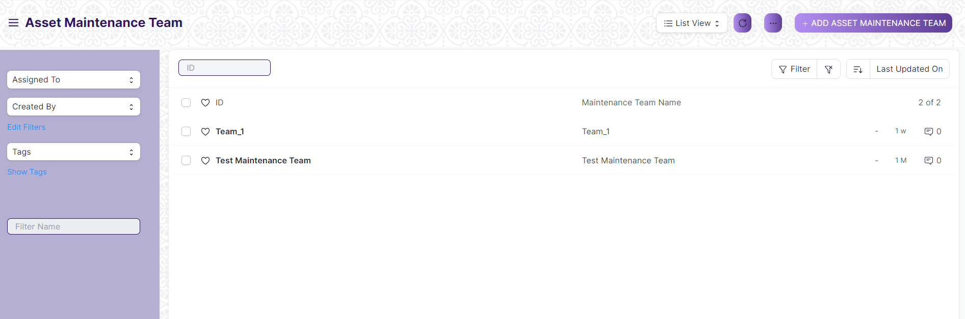

(List View of Asset Maintenance Team)

**View Asset Maintenance Team**

As it is a Save screen, follow the general procedure to view a Save document as mentioned above .

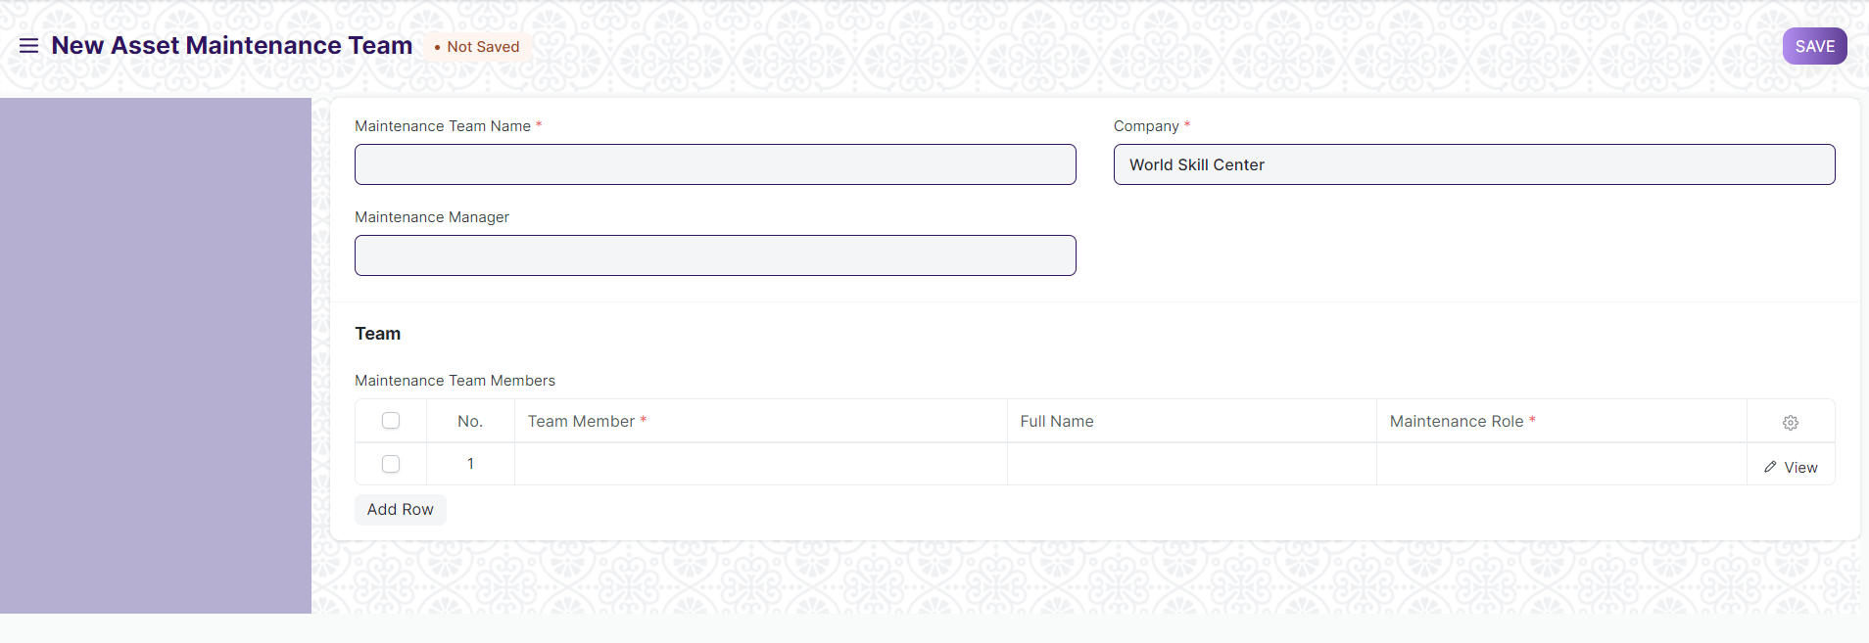

(View of a Save Asset Maintenance Team)

**Delete Asset Maintenance Team**

As it a Save screen , follow the general procedure to delete a Save document .

**Edit Asset Maintenance Team**

Edit the field that you want to change.

Click on Save.

**Print Asset Maintenance Team**

As it is a Save screen , follow the general procedure to print a Save document.

## Asset Maintenance

Asset Maintenance refers to any activity done on Assets to maintain their performance or condition.

To track the details of individual maintenance/calibration tasks for an asset by date, the person responsible for the maintenance, and future maintenance due date.

The screen is accessible to Building Administrator, Floor Supervisor, Maintenance Department, Employee

To access the Asset Maintenance ,go to :

***Home > Infrastructure Management & Maintenance >Asset Maintenance > Asset Maintenance***

Screen Type : Save

**Adding a new Asset Maintenance**

As it is a Save screen, follow the general procedure to create a Save document as mentioned above .

* Go to the Asset Maintenance list, click on New.
* Select the Asset.
* Select the Asset Maintenance Team.
* Add Maintenance Tasks in the table.
* Set the Maintenance Status whether 'Planned', 'Overdue', or 'Canceled'.
* Select a periodicity for which the task needs to be carried out. The next due date will be calculated.
* Click on Save.
* After saving, you can assign the task to a user.
* If the Item is serialized, the Serial Number can be entered.

After creating an Asset Maintenance , the record will be visible in the List view of the screen.

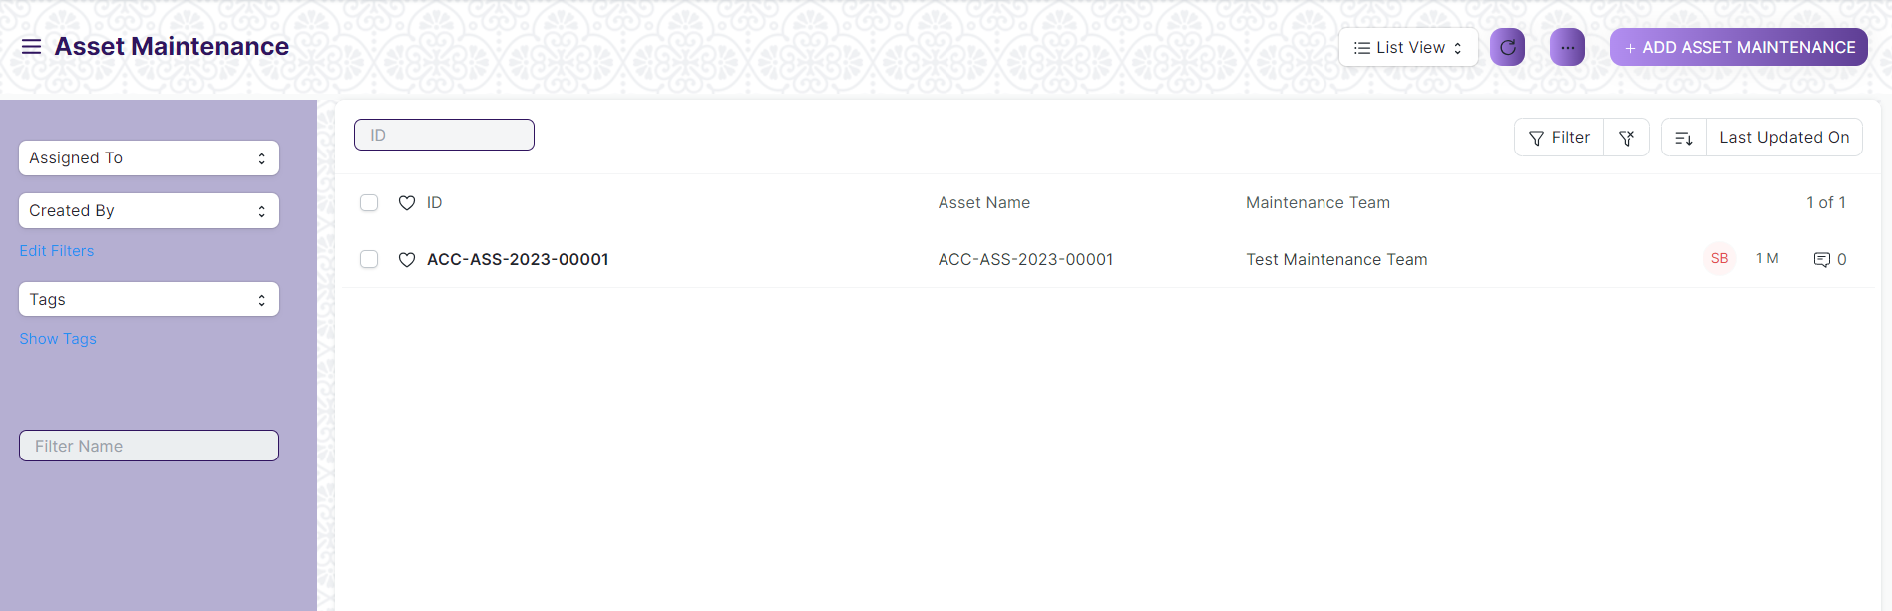

(List View of Asset Maintenance)

**View Asset Maintenance**

As it is a Save screen, follow the general procedure to view a Save document as mentioned above .

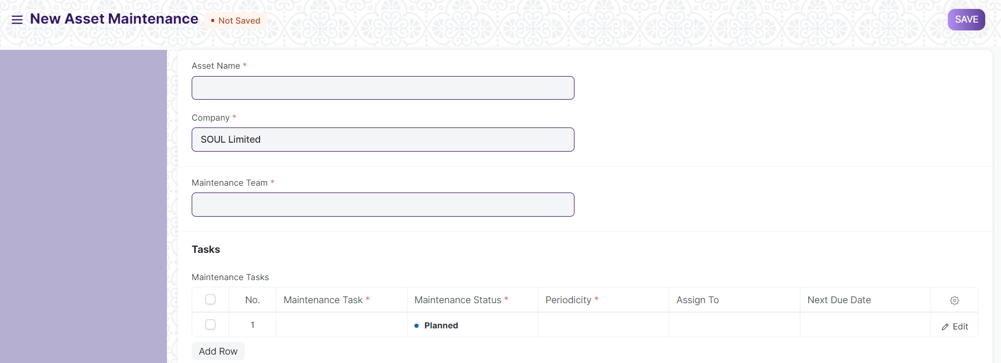

(View of a Save Asset Maintenance)

**Delete Asset Maintenance**

As it a Save screen , follow the general procedure to delete a Save document .

**Edit Asset Maintenance**

Edit the field that you want to change.

Click on Save.

**Print Asset Maintenance**

As it is a Save screen , follow the general procedure to print a Save document.

## Asset Maintenance

Asset Maintenance Log logs the tasks carried out in an Asset Maintenance.

For each task in Asset Maintenance, Asset Maintenance Log is auto created to keep track of the upcoming maintenance's. It will have a status, completion date and actions performed. Based on completion date here, next due date is calculated automatically and new Asset Maintenance Log is created.

The screen is accessible to Building Administrator, Floor Supervisor, Maintenance Department, Employee

To access the Asset Maintenance Log, go to :

***Home > Infrastructure Management & Maintenance >Asset Maintenance > Asset Maintenance Log***

Screen Type : Submit

**Adding a new Asset Maintenance Log**

A Draft of the Asset Maintenance Log is created as scheduled in the Asset Maintenance form. In order to submit an Asset Maintenance Log, the Asset Maintenance status has to either 'Completed' or 'Canceled'.

After creating an Asset Maintenance , the record will be visible in the List view of the screen.

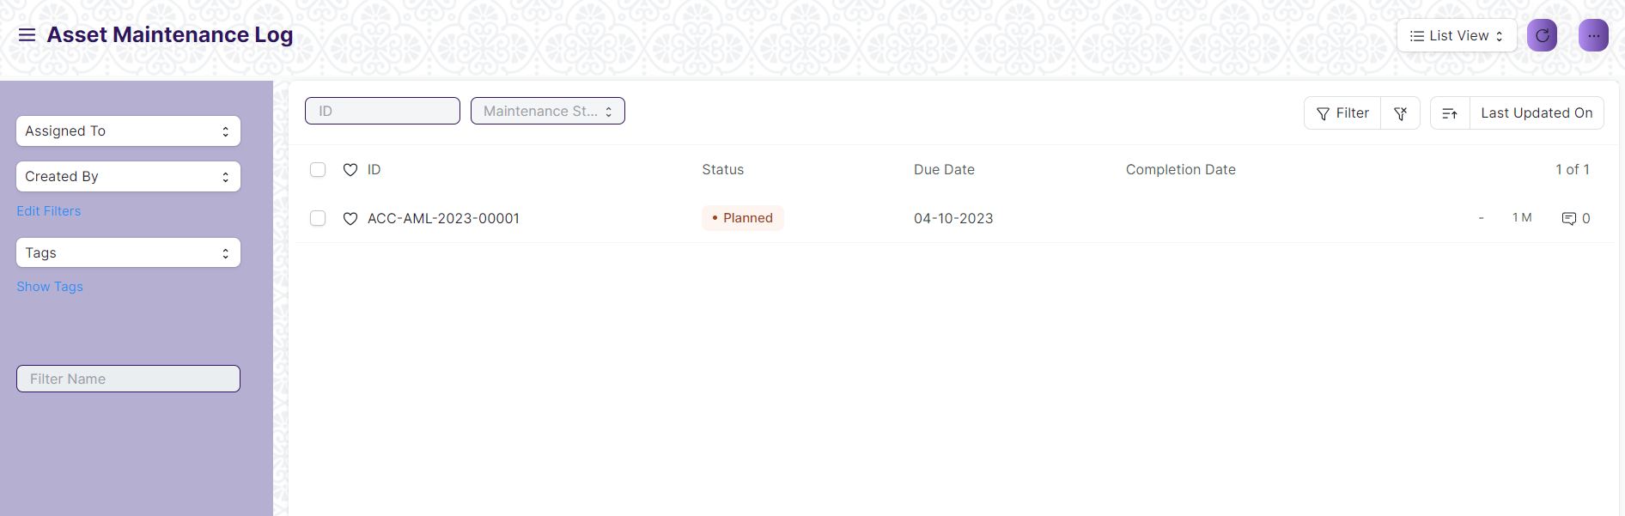

(List View of Asset Maintenance Log)

**View Asset Maintenance Log**

As it is a Submit screen, follow the general procedure to view a Submit document as mentioned above .

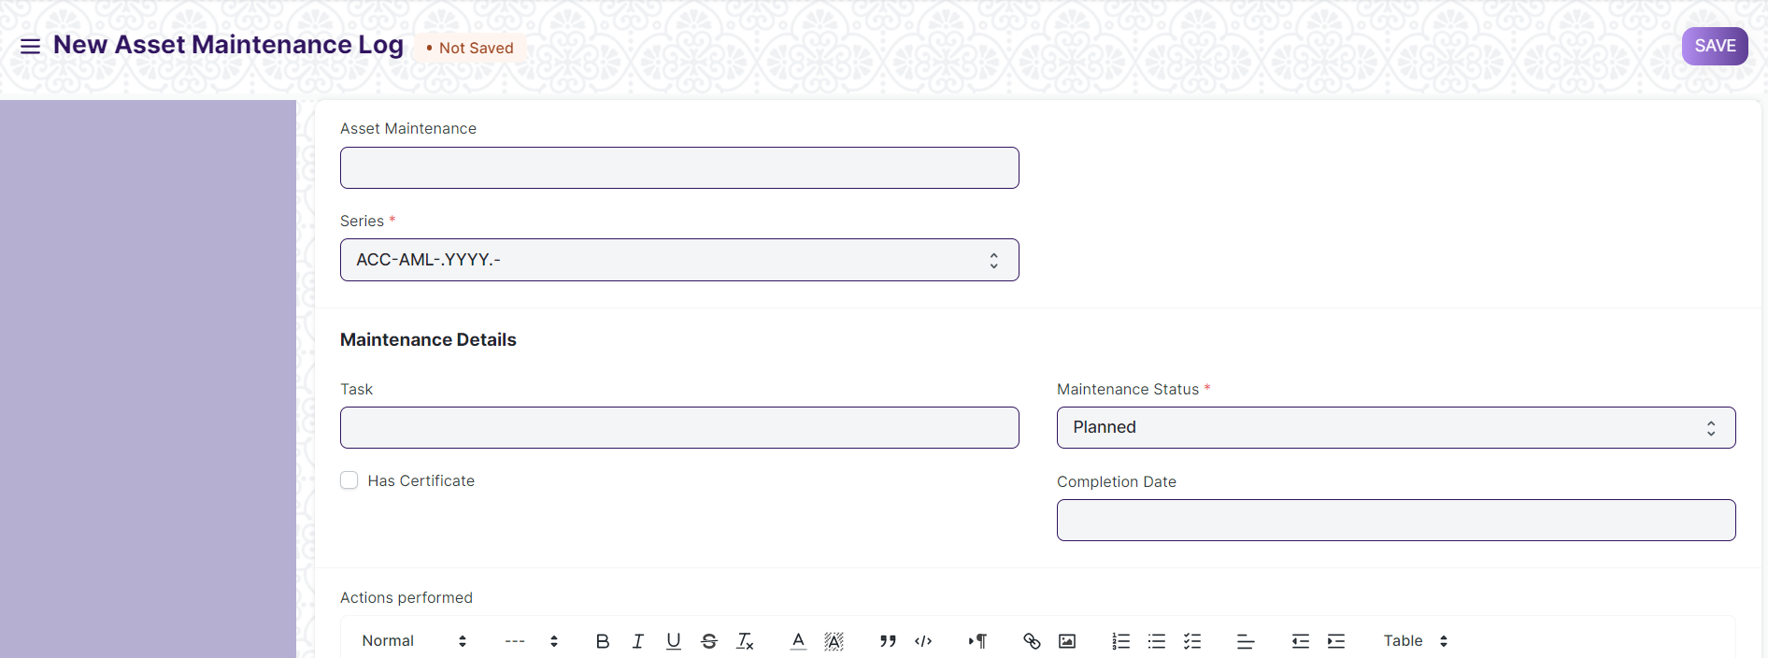

(View of a Submit Asset Maintenance Log)

**Delete Asset Maintenance Log**

As it a Submit screen , follow the general procedure to delete a Submit document .

**Edit Asset Maintenance Log**

Edit the field that you want to change.

Click on Submit.

**Print Asset Maintenance Log**

As it is a Submit screen , follow the general procedure to print a Submit document.

## Asset Maintenance

Asset Repair refers to any activity carried to repair a broken Asset to restore full functionality.

You can also maintain the records of Repair/Failures of Assets which are not listed in Asset Maintenance.

The screen is accessible to Building Administrator, Floor Supervisor, Maintenance Department, Employee

To access the Asset Maintenance Log, go to :

***Home > Infrastructure Management & Maintenance >Asset Maintenance > Asset Repair***

Screen Type : Save

**Adding a new Asset Repair**

A Draft of the Asset Maintenance Log is created as scheduled in the Asset Maintenance form. In order to submit an Asset Maintenance Log, the Asset Maintenance status has to either 'Completed' or 'Canceled'.

After creating an Asset Maintenance , the record will be visible in the List view of the screen.

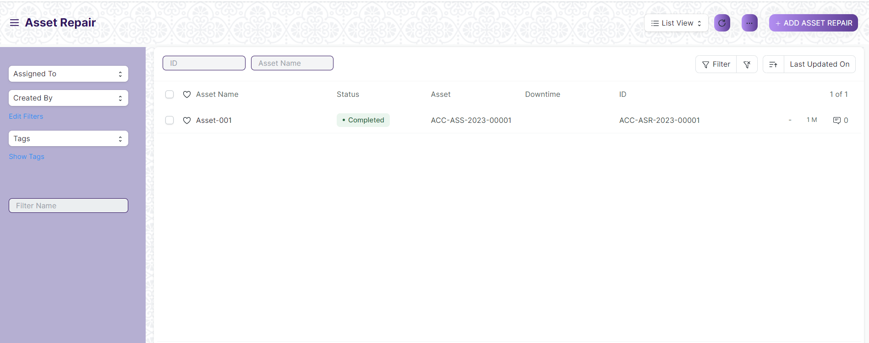

(List View of Asset Repair)

**View Asset Repair**

As it is a Save screen, follow the general procedure to view a Save document as mentioned above .

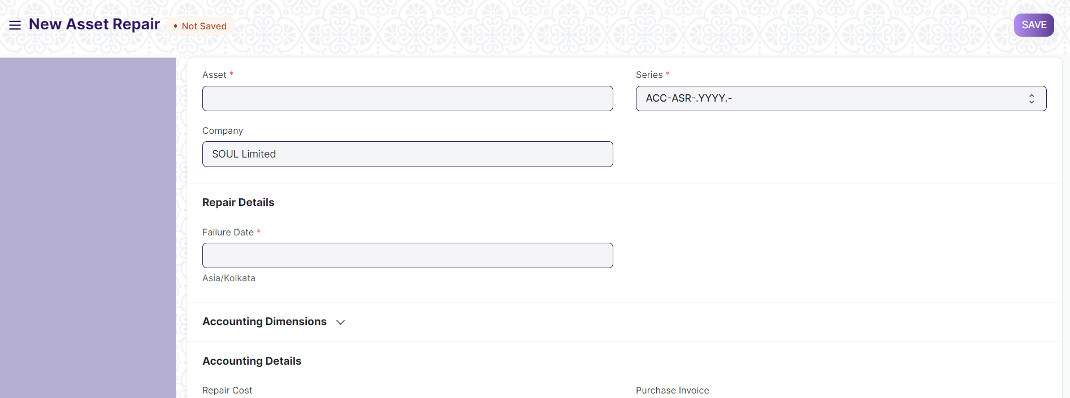

(View of a Save Asset Repair)

**Delete Asset Repair**

As it a Save screen , follow the general procedure to delete a Save document .

**Edit Asset Repair**

Edit the field that you want to change.

Click on Save.

**Print Asset Repair**

As it is a Save screen , follow the general procedure to print a Save document.

# Roles and Permissions

## Land

|  |  |  |  |  |  |  |  |  |  |  |
| --- | --- | --- | --- | --- | --- | --- | --- | --- | --- | --- |
| **ID** | | **Role** | **Select** | **Read** | **Write** | **Create** | **Delete** | **Submit** | **Cancel** | **Amend** |
| 1 | Building Administrator | | Yes | Yes | Yes | Yes | Yes | NA | NA | NA |
| 2 | Floor Supervisor | | No | Yes | No | No | No | NA | NA | NA |
| 3 | Maintenance Department | | No | Yes | No | No | No | NA | NA | NA |
| 4 | Employee | | No | No | No | No | No | No | No | No |

## Buildings

|  |  |  |  |  |  |  |  |  |  |
| --- | --- | --- | --- | --- | --- | --- | --- | --- | --- |
| **ID** | **Role** | **Select** | **Read** | **Write** | **Create** | **Delete** | **Submit** | **Cancel** | **Amend** |
| 1 | Building Administrator | Yes | Yes | Yes | Yes | Yes | NA | NA | NA |
| 2 | Floor Supervisor | No | Yes | No | No | No | NA | NA | NA |
| 3 | Maintenance Department | No | Yes | No | No | No | NA | NA | NA |
| 4 | Employee | No | No | No | No | No | NA | NA | NA |

## Floor

|  |  |  |  |  |  |  |  |  |  |  |
| --- | --- | --- | --- | --- | --- | --- | --- | --- | --- | --- |
| **ID** | | **Role** | **Select** | **Read** | **Write** | **Create** | **Delete** | **Submit** | **Cancel** | **Amend** |
| 1 | Building Administrator | | Yes | Yes | Yes | Yes | Yes | NA | NA | NA |
| 2 | Floor Supervisor | | No | Yes | No | No | No | NA | NA | NA |
| 3 | Maintenance Department | | No | Yes | No | No | No | NA | NA | NA |
| 4 | Employee | | No | No | No | No | No | NA | NA | NA |

## Building Type room

|  |  |  |  |  |  |  |  |  |  |
| --- | --- | --- | --- | --- | --- | --- | --- | --- | --- |
| **ID** | **Role** | **Select** | **Read** | **Write** | **Create** | **Delete** | **Submit** | **Cancel** | **Amend** |
| 1 | Building Administrator | Yes | Yes | Yes | Yes | Yes | NA | NA | NA |
| 2 | Floor Supervisor | No | Yes | No | No | No | NA | NA | NA |
| 3 | Maintenance Department | No | Yes | No | No | No | NA | NA | NA |
| 4 | Employee | No | No | No | No | No | NA | NA | NA |

## Building Room

|  |  |  |  |  |  |  |  |  |  |  |
| --- | --- | --- | --- | --- | --- | --- | --- | --- | --- | --- |
| **ID** | | **Role** | **Select** | **Read** | **Write** | **Create** | **Delete** | **Submit** | **Cancel** | **Amend** |
| 1 | Building Administrator | | Yes | Yes | Yes | Yes | Yes | NA | NA | NA |
| 2 | Floor Supervisor | | No | Yes | No | No | No | NA | NA | NA |
| 3 | Maintenance Department | | No | Yes | No | No | No | NA | NA | NA |
| 4 | Employee | | No | No | No | No | No | NA | NA | NA |

## Asset

|  |  |  |  |  |  |  |  |  |  |
| --- | --- | --- | --- | --- | --- | --- | --- | --- | --- |
| **ID** | **Role** | **Select** | **Read** | **Write** | **Create** | **Delete** | **Submit** | **Cancel** | **Amend** |
|  | Building Administrator | Yes | Yes | Yes | Yes | Yes | Yes | Yes | Yes |
|  | Floor Supervisor | Yes | Yes | Yes | Yes | Yes | Yes | Yes | Yes |
|  | Maintenance Department | Yes | Yes | Yes | Yes | Yes | Yes | Yes | Yes |
|  | Employee | Yes | Yes | No | No | No | No | No | No |

## Asset Maintenance Team

|  |  |  |  |  |  |  |  |  |  |
| --- | --- | --- | --- | --- | --- | --- | --- | --- | --- |
| **ID** | **Role** | **Select** | **Read** | **Write** | **Create** | **Delete** | **Submit** | **Cancel** | **Amend** |
|  | Building Administrator | No | Yes | No | No | No | No | No | No |
|  | Floor Supervisor | No | Yes | No | No | No | No | No | No |
|  | Maintenance Department | Yes | Yes | Yes | Yes | Yes | Yes | Yes | Yes |
|  | Employee | No | Yes | No | No | No | No | No | No |

## Asset Maintenance

|  |  |  |  |  |  |  |  |  |  |
| --- | --- | --- | --- | --- | --- | --- | --- | --- | --- |
| **ID** | **Role** | **Select** | **Read** | **Write** | **Create** | **Delete** | **Submit** | **Cancel** | **Amend** |
|  | Building Administrator | No | Yes | No | No | No | No | No | No |
|  | Floor Supervisor | No | Yes | No | No | No | No | No | No |
|  | Maintenance Department | Yes | Yes | Yes | Yes | Yes | Yes | Yes | Yes |
|  | Employee | No | Yes | No | No | No | No | No | No |

## Asset Maintenance

|  |  |  |  |  |  |  |  |  |  |
| --- | --- | --- | --- | --- | --- | --- | --- | --- | --- |
| **ID** | **Role** | **Select** | **Read** | **Write** | **Create** | **Delete** | **Submit** | **Cancel** | **Amend** |
|  | Building Administrator | No | Yes | No | No | No | No | No | No |
|  | Floor Supervisor | No | Yes | No | No | No | No | No | No |
|  | Maintenance Department | Yes | Yes | Yes | Yes | Yes | Yes | Yes | Yes |
|  | Employee | No | Yes | No | No | No | No | No | No |

## Asset Maintenance

|  |  |  |  |  |  |  |  |  |  |
| --- | --- | --- | --- | --- | --- | --- | --- | --- | --- |
| **ID** | **Role** | **Select** | **Read** | **Write** | **Create** | **Delete** | **Submit** | **Cancel** | **Amend** |
|  | Building Administrator | No | Yes | No | No | No | No | No | No |
|  | Floor Supervisor | No | Yes | No | No | No | No | No | No |
|  | Maintenance Department | Yes | Yes | Yes | Yes | Yes | Yes | Yes | Yes |
|  | Employee | No | Yes | No | No | No | No | No | No |